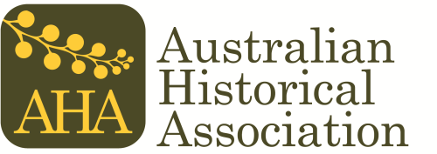
The Ann Curthoys Prize

Application Form 2022

Title of submission: Click here to enter text.

Full name: Click here to enter text.

Institutional affiliation (if any): Click here to enter text.

Email: Click here to enter text.

Phone no: Click here to enter text.

Please read each point below and tick the box to indicate your agreement. Applications submitted without this agreement will not be eligible for consideration by the panel.

- I confirm that I graduated with a PhD no more than five years before 1 May 2022.
- I confirm that this submission is my own work, that all debts to other scholars have been appropriately acknowledged, and that all sources have been appropriately referenced.
- I confirm that, should this submission win the Ann Curthoys Prize, History Australia will have the opportunity to consider the submission for publication. I will not offer it for publication elsewhere until History Australia has advised the outcome.

Signed: ________________________________ Dated: __________________

